Human Heart

Prereading

Bricks in the platform.

Learning Objectives

After completing this brick, you will be able to:

* Learning objective 1
* Learning objective 2
* Learning objective …

Case Connection

What is [Title of Brick]?

The human heart is an organ that pumps blood throughout the body via the vessels of the circulatory system, supplying oxygen and nutrients to the tissues and removing carbon dioxide and other wastes. The pericardium serves to protect the heart and anchor it inside the chest. Pericardial fluid acts as a lubricant between the outer layer, the parietal pericardium, and the inner layer, the serous pericardium. The right atrium and right ventricle together make up the "right heart," and the left atrium and left ventricle make up the "left heart." A wall of muscle called the septum separates the two sides of the heart. The pulmonary semi-lunar valve separates the right ventricle from the pulmonary artery, and the aortic valve separates the left ventricle from the aorta. In the pulmonary circuit, deoxygenated blood leaves the right ventricle of the heart via the pulmonary artery and travels to the lungs; then the oxygenated blood returns through the pulmonary vein to the left atrium of the heart, according to the journal Biomedical Sciences. Of course, the heart is also a muscle, so it needs a fresh supply of oxygen and nutrients, too, Phillips said. Blockage of any of these arteries can cause a heart attack, or damage to the heart muscle, Phillips said. Then the ventricles continue contracting while empty.

Header for Learning Objective 1?

Narrative text

## Header 2

Narrative text

**Header 3.** Narrative text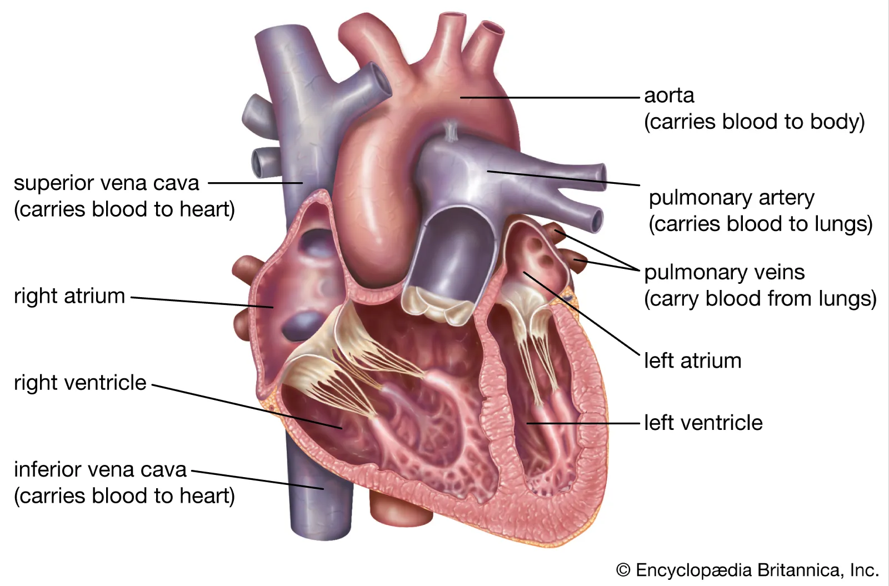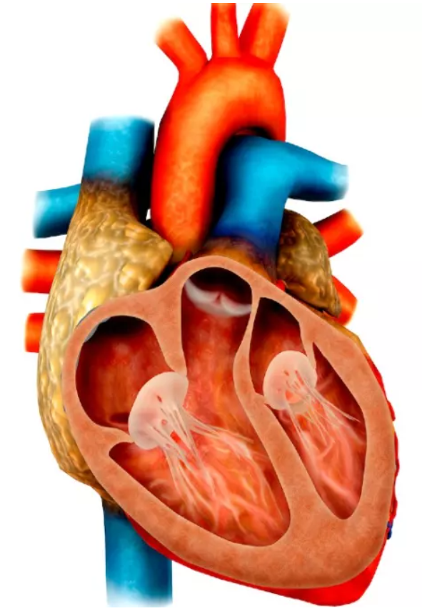

Figure 1 Short descriptive title

Q: [insert question]

A: [paragraph with the answer]

Other pedagogical elements

Case Connection

Summary

## Header for learning objective 1

* Summary point 1
* Summary point 2
* Summary point…

## Header for learning objective 2

Review Questions

1. Question 1

1. Option A
2. Option B (Correct answer)
3. Option C
4. Option D
5. Option E

2. Question 2

1. Option A
2. Option B (Correct answer)
3. Option C
4. Option D
5. Option E

3. Question 3

1. Option A
2. Option B (Correct answer)
3. Option C
4. Option D
5. Option E

Answers

1. Explanation of review question 1

2. Explanation of review question 2

3. Explanation of review question 3

**References**

**Figures**

Provide additional information about your images/illustrations here (CDN number, or if you want something drawn provide an example image here.)

|  |  |  |  |
| --- | --- | --- | --- |
| **ARTWORK** | | | |
| **Fig #** | **Description of Figure** | **Figure Source (CDN #, link, or citation)**  **\*\*Search the DAM first!\*\*** | **Modifications to Figure (if any) --**  **Detailed instructions to Art Team** |
|  | *EXAMPLES:* |  |  |
| *Fig 1* | *Cardiac conduction system* | *DAM CDN 13339* | * Delete action potentials on right side of image * Keep the rest of the texts and labels the same * Redraw the image as is in this example, keeping similar colors |
| *Fig 2* | *Pacemaker action potential* | *DAM CDN 13345* | * Add labels to graph as shown in brick |
| *Fig 3* | *Two AV nodal pathways & re-entry circuit* | *http://www.washingtonhra.com/arrhythmias/av-nodal-reentrant-tachycardia-avnrt.php* | * Pick up or redraw out of copyright |
|  |  |  |  |
|  |  |  |  |
|  |  |  |  |
|  |  |  |  |
|  |  |  |  |